**MIND STORM SOFTWARE PVT LTD**  
**Android Development Training**

**Android Development Environment Setup**

Copy the **android-training** folder into **c:\** folder. All the files are present in **c:\android-training** folder.

We need the following software installed:

* Java Software Development Kit (JDK) (both 32-bit and 64-bit bundles are present)
* Android ADT Bundle (both 32-bit and 64-bit bundles are present)

Now follow the steps given below:

**Java Software Development Kit installation**

**If you already have an existing JDK Installation, skip this step and go to the ADT Installation**

1. Go to **c:\android-training** folder.
2. Double-click the file **jdk-7u11-windows-i586.exe (32-bit)** or **jdk-7u11-windows-x64.exe (64-bit)**
3. Proceed with all the default steps.
4. Complete the installation.

**ADT Installation**

1. Go to **c:\android-training** folder.
2. Unzip the file **adt-bundle-windows-x86.zip** (32-bit) or **adt-bundle-windows-x86_64.zip** (64-bit) into the same folder.
3. It will unzip the ADT and you will have either a folder named **adt-bundle-windows-x86** (32-bit) or **adt-bundle-windows-x86_64** (64-bit).
4. Inside the above folder, you will find the following structure

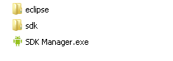

**Launch Eclipse**

1. Launch Eclipse.exe. It is present in **c:\android-training\<ADT-Bundle-Folder>\eclipse** folder.
2. It will display a Workspace Launcher dialog and will ask for a Workspace location. Replace the default value with **c:\android-training\workspace** and click on OK.
3. Close the Welcome window.
4. You should see the screen as shown below:

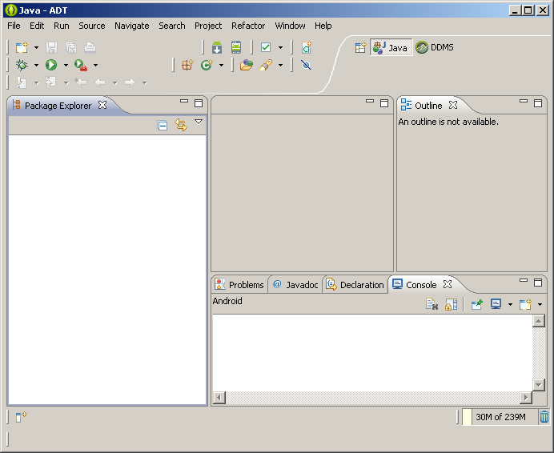

1. From the Main menu, go to **Window 🡪 Preferences** and click on **Android**.
2. You will see the window shown below:

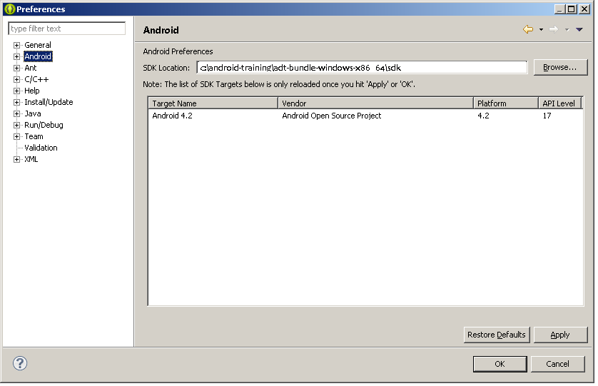

1. You should see the Android 4.2 SDK shown in the list as shown above.
2. Click on OK.

Congratulations! You are now all set to dive into Android Development.